Greetings Meadowlake Residents,
Wake up everybody no more sleepin' in bed
No more backward thinkin' time for thinkin' ahead
The world has changed so very much from what it used to be
There is so much hatred war an' poverty
Wake up all the teachers time to teach a new way
Maybe then they'll listen to whatcha have to say
'Cause they're the ones who's coming up and the world is in their hands
When you teach the children teach em the very best you can
The world won't get no better if we just let it be
The world won't get no better we gotta change it yeah, just you and me…

The above lyrics to the song “Wake Up Everybody” was released in 1975 by Teddy Pendergrass, but seems to have more meaning and relevance today. With all the influences of social media, TV, politics, legalization of certain drugs, access to illegal weapons, etc… our community and children are going to suffer unless we stop “sleepin” and start “thinkin” ahead.

Since June is the beginning of summer and an opportunity to get outside and enjoy not just the weather, but your community. There are several events happening throughout the summer that will give every household, all ages, occasions for fun and fellowship around Richton Park.

As a 20 year resident of MLE, Sunset Drive, I’m really looking forward to meeting more neighbors at our next members/resident board meeting on June 27th….so that I can explain why Sunset is the BEST block in the subdivision…GO SUNSET, GO SUNSET…

Best Regards,
Patrick Napue
Patrick Napue, MLE HOA Interim Vice President 2018-2019

Special Thanks
Meadowlake Estates would like to send a special Thank You to for the donation of the beautiful wreath! Please stop and take a moment, if you already haven’t, to observe the wreath and our entryway! |  | Thank You to Mr. Tommie Garner for his commitment in leadership and service to our Block Captain’s Committee. Without his support, our newsletters, flyers and other neighborhood information would not reach our mailboxes each month. Thank You!!! |  | Thank you and welcome, to Mr. Larry Newman who is our new Beautification Committee Leader for the 2018-2019 term. Mr. Newman has regularly been seen at our Christina Covington Park and teaming up with our Richton Park Parks & Recreation, to oversee that our park remains clean, manicured and beautiful for all to see. Thank you again Mr. Newman for your amazing work!!!!
ACKNOWLEDGEMENTS |  |  | DUES, DUES….OH, AND DUES!!!!
Welcome our new neighbors Mr. Keith and Pat Richardson to the community! Also, our sincere condolences in the loss of your family member.  Thank you to Jesse Greer for the electrician work provided during our Comcast clean up day!  We ask that if you know of any new residents to the community to please advise any board member.  We are also seeking donations and/or a reef to decorate the front entry. |  |  | MEADOWLAKE MEMBERSHIP DUES ARE DUE FOR THE 2018-2019 YEAR!!!!! THE FEE IS $40 PER FAMILY. YOUR DUES AND DONATIONS GO TOWARDS ALL YEARLY EVENTS, TOWARDS THE BEAUTIFICATION FOR OUR ENTRYWAY, OUR BACK-TO-SCHOOL EVENTS FOR OUR KIDS, ETC. PLEASE SUPPORT YOUR MLE COMMUNITY TODAY!!!! CONTACT TREASURER, ANNETTE WARE AT (708) 283-8540  AS A CONVIENCE, WE HAVE ATTACHED THE MEMBERSHIP APPLICATION. It’s never too late to join your HOA!! Your presence and efforts are NEEDED and APPRECIATED!!!!!!

Upcoming Events
Meadowlake Estates HOA

Monthly Meeting

Thursday

August 23, 2018

7:30pm

Richton Park

Village Hall

Board Room
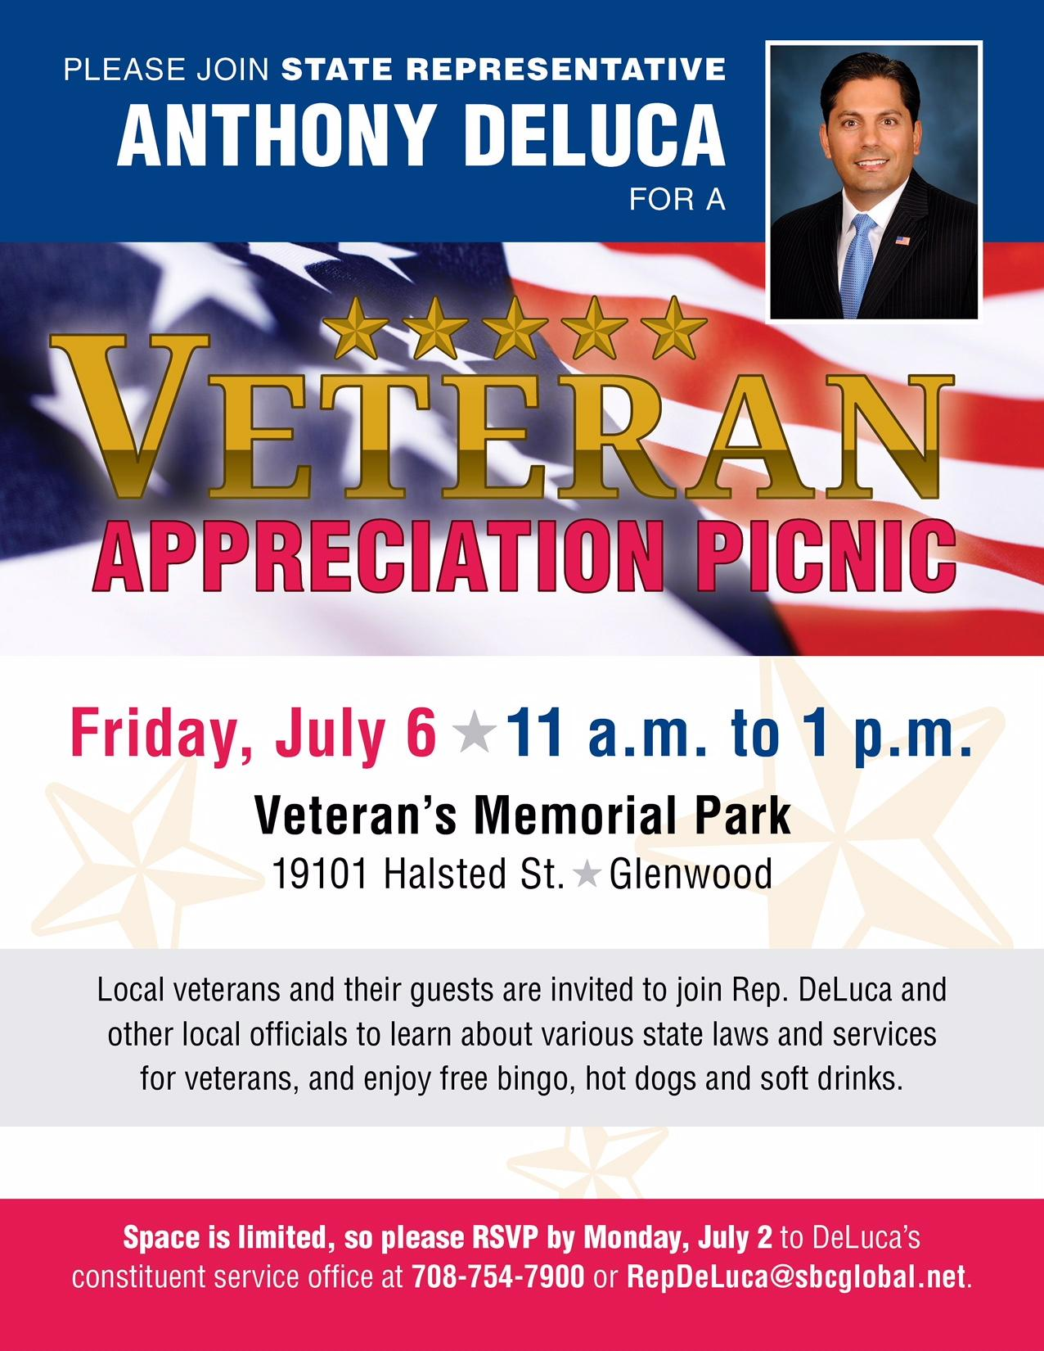 |  | 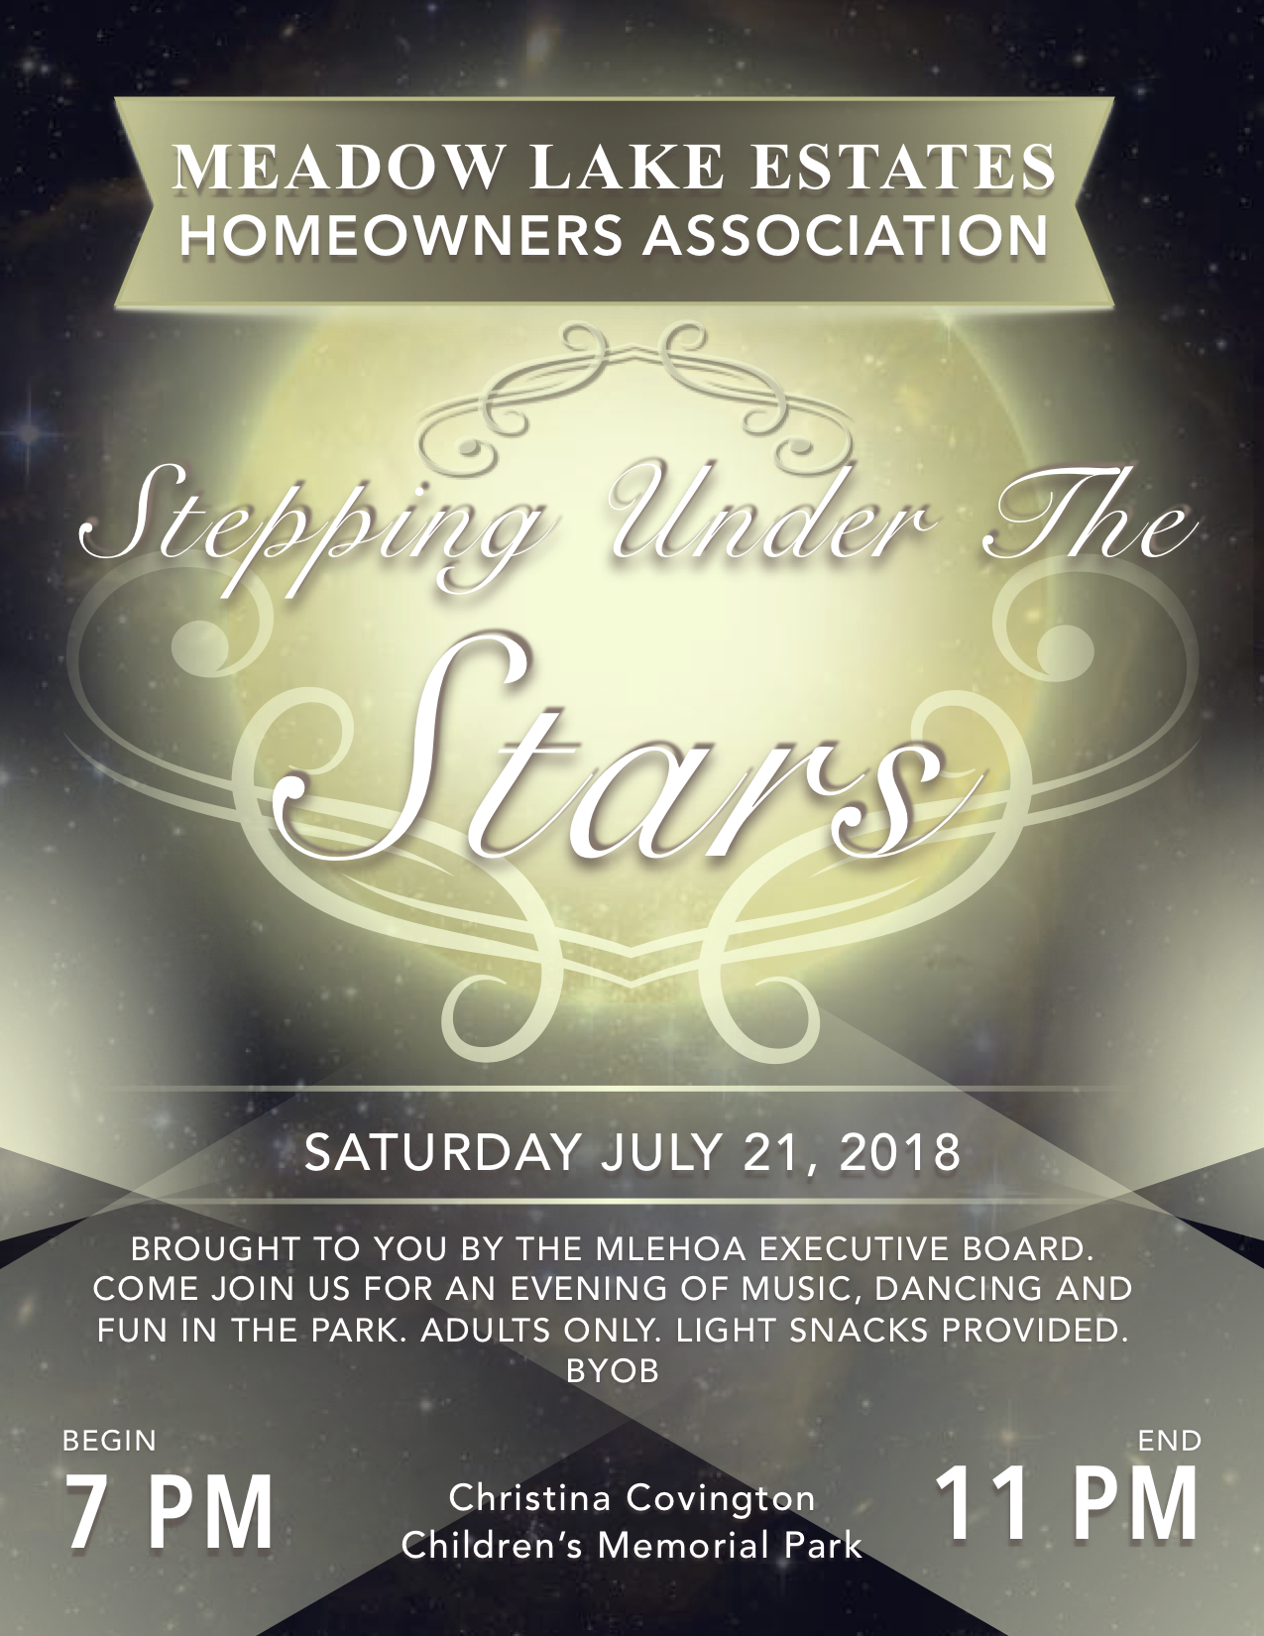 |  | 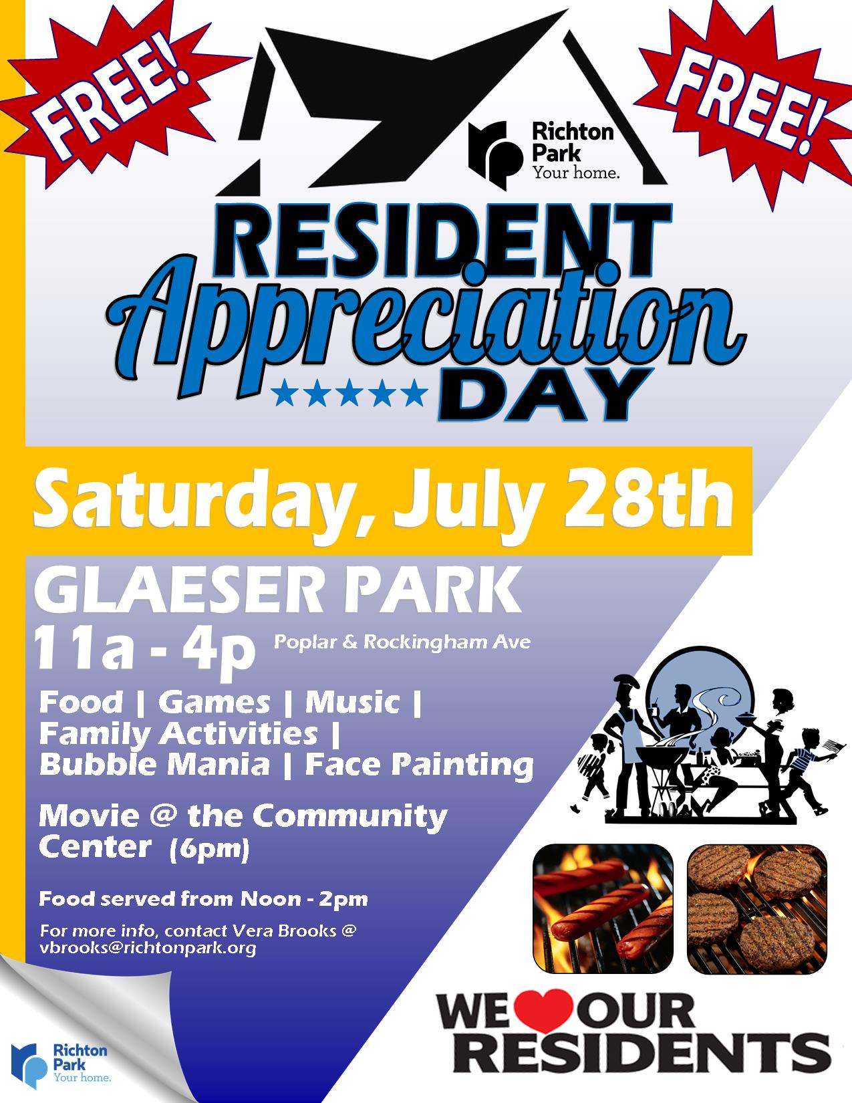
EXECUTIVE BOARD  Carl Scott - President  (773) 610-7733  Annette Ware - Treasurer  (708) 828-0955  Dreyanna Scott - Secretary  (708) 522-1240  Aaron Reaves - Sgt. at Arms  (630) 926-4185  MLE CONTACT  meadowlakeestates.hoa@gmail.com |  | BLOCK CAPTAINS  Tommie Garner: Chairman 747-9889 Dan Brown: Meadowlake Drive 748-6553 Scot Scott: Meadowlake Drive 275-8619 Carolyn Brown: Meadowlake Place 860-8526 Steve Tyson: Brook Ave 552-6397 Rosie Dagon: Meadowlake Court 481-6253 Larry Newman: Spring Lane/Court: 481-8503 Henry Ehizemwogie: Meadowlake Drive (773) 574-4825 Jerry Rials: Sunset Drive 747-6520 Darnell Langston: Capri Lane 420-6316 Sherman Hollivay: Harbor Lane 285-4344 Shawntora Harvey: Harbor Lane (773) 909-9325 Annette Ware: Bayview Drive 828-0955 Sharon Kriha: MLE back-up 567-0534

__________________________________________________________________________________________

Village of Richton Park Directory:

Administration : (708) 481-8950
Community Center : (708) 753-8800
Community Services : (708) 753-8800
Parks & Recreation : (708) 753-8800
Community & Economic Development : (708) 481-5086
Code Enforcement : (708) 481-8950
Finance : (708) 481-8950
Fire Department (Non Emergency) : (708) 481-8985
Police (Non Emergency) : (708) 283-6393
Police (Dispatch) : (708) 481-8911
Public Works : (708) 481-8950

