Hello Everyone,
With all of the tension between people and law enforcement, we’d like to take the time to thank the Richton Park Police Department for working as partners within our community. We’ve had recent issues within our own subdivision which have required police action. The RPPD has always been responsive and respectful to our residents. Outside of our village, we do not always experience the same mutual understanding with police. As part of our July meeting Carl Scott, our Vice President, active federal agent and security consultant will provide tips for neighborhood safety and interacting with police. He has over 17 years in law enforcement (10 years as a local police officer and 7.5 years as a federal agent). Mr. Scott is currently the owner of a security company Supreme Security Consultants Inc. This will be a precursor to a forthcoming symposium to be held on similar topics. Please come out and join the conversation. Bring your family and a neighbor. We will see you at the meeting.
- From the desk of MLE President Antonio Belton

GENERAL NEWS

CONGRATULATIONS  Our very own Meadowlake Estates Treasurer Annette Ware has been awarded the Age Options Volunteer Award for 2016! Congratulations Annette from your Meadowlake Family!!! | With Pride and Joy: James and Sheila Townsel proudly announce the graduation of their daughter Tiffany V. Townsel, DDS, from Meharry Medical College School of Dentistry

UPCOMING EVENTS

FAMILY AFFAIR

Oh yeah, Oh yeah!!! It’s time for our annual fest where residents can enjoy a fun filled day with a bubble machine, food, games, music, and raffles that the whole family will love!!! This year we will also have a congratulatory gift for all of our graduates and more that you won’t want to miss!! Come on out to meet your neighbors and have a good time!!

Saturday, July 30th, 2016 at 11am-4pm
Christina Covington Children’s Memorial Park

* This is a free event*
* We would appreciate any volunteers for servers*
* Donations will be accepted and appreciated for this event*
* Please submit your graduates name at the HOA meeting on June23rd, 2016*

WINE TASTING 201- FRIENDS OF RICHTON PARK LIBRARY

Wine is just fine. Come on out for entertainment and more. Adults only event. DJ Maurice Joshua on the 1’s and 2’s. Tickets are $25 in advance and $30 at the door. Don’t hesitate to purchase now. Additional information will be provided at the HOA meeting.

Saturday, July 30th, 2016 at 5pm-8pm
Richton Park Library
22310 Latonia Ln , Richton Park

RICHTON PARK NATIONAL NIGHT OUT
Come join the police and community take a stand against crime. Lock your doors, turn on the porch light and meet us in the park for food, fun and fellowship!!!
THERE WILL BE FIREWORKS AT DUSK!!!!

Tuesday, August 2nd, 2016 at 6:30-9pm
Glaeser Park
Poplar Avenue and Rockingham Rd,
Richton Park, IL

HIGHLIGHTS

MOONLIGHT & MAGIC
This year’s Moonlight & Magic prom was a huge success!! Everyone looked stunning in their formal wear and the party didn’t stop until 11pm. Thank you to all who attended and 2018 will be even better. Congratulations to Mr. Darnell Langston and Mrs. Joyce Weems on being crowned Prom King and Queen!!

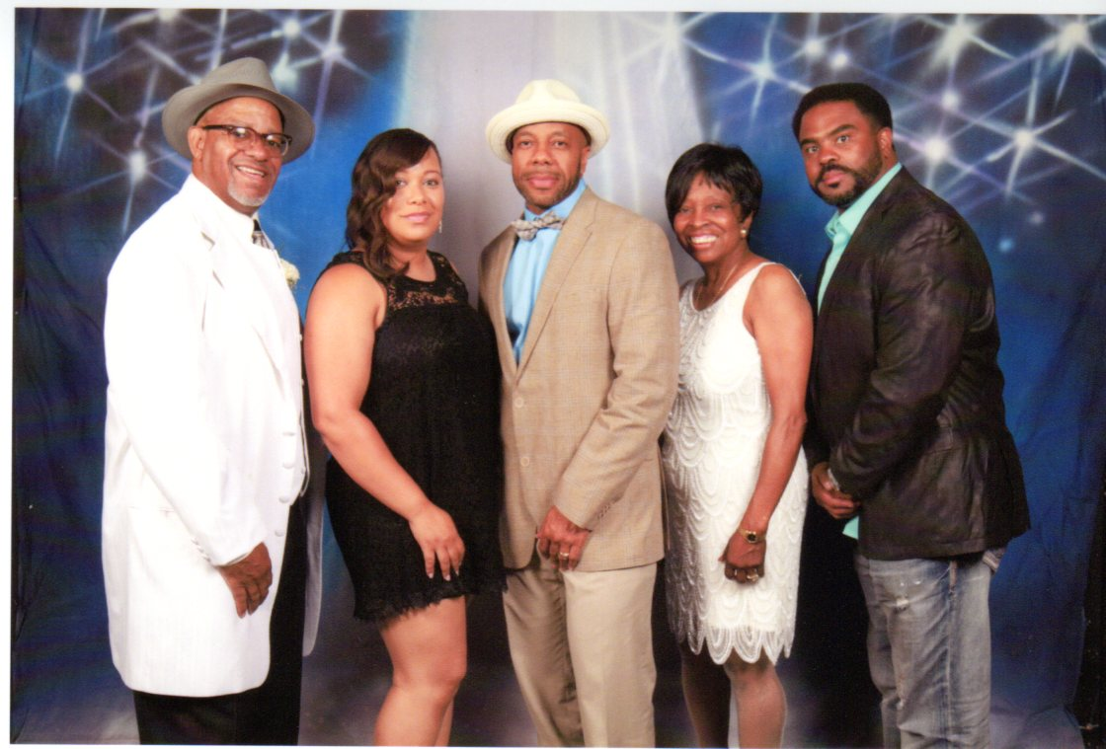
RESIDENT APPRECIATION DAY

Our annual Resident Appreciation Day was a blast. Great food music, prizes and games and the bubble machine was a crowd favorite!!! We can’t wait til next year!!!

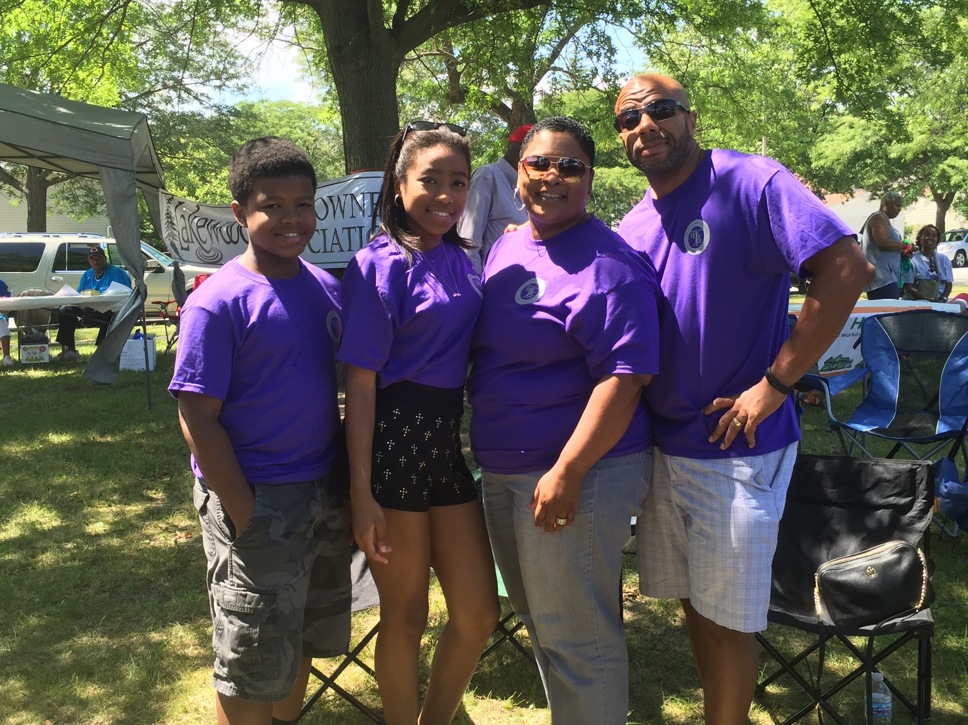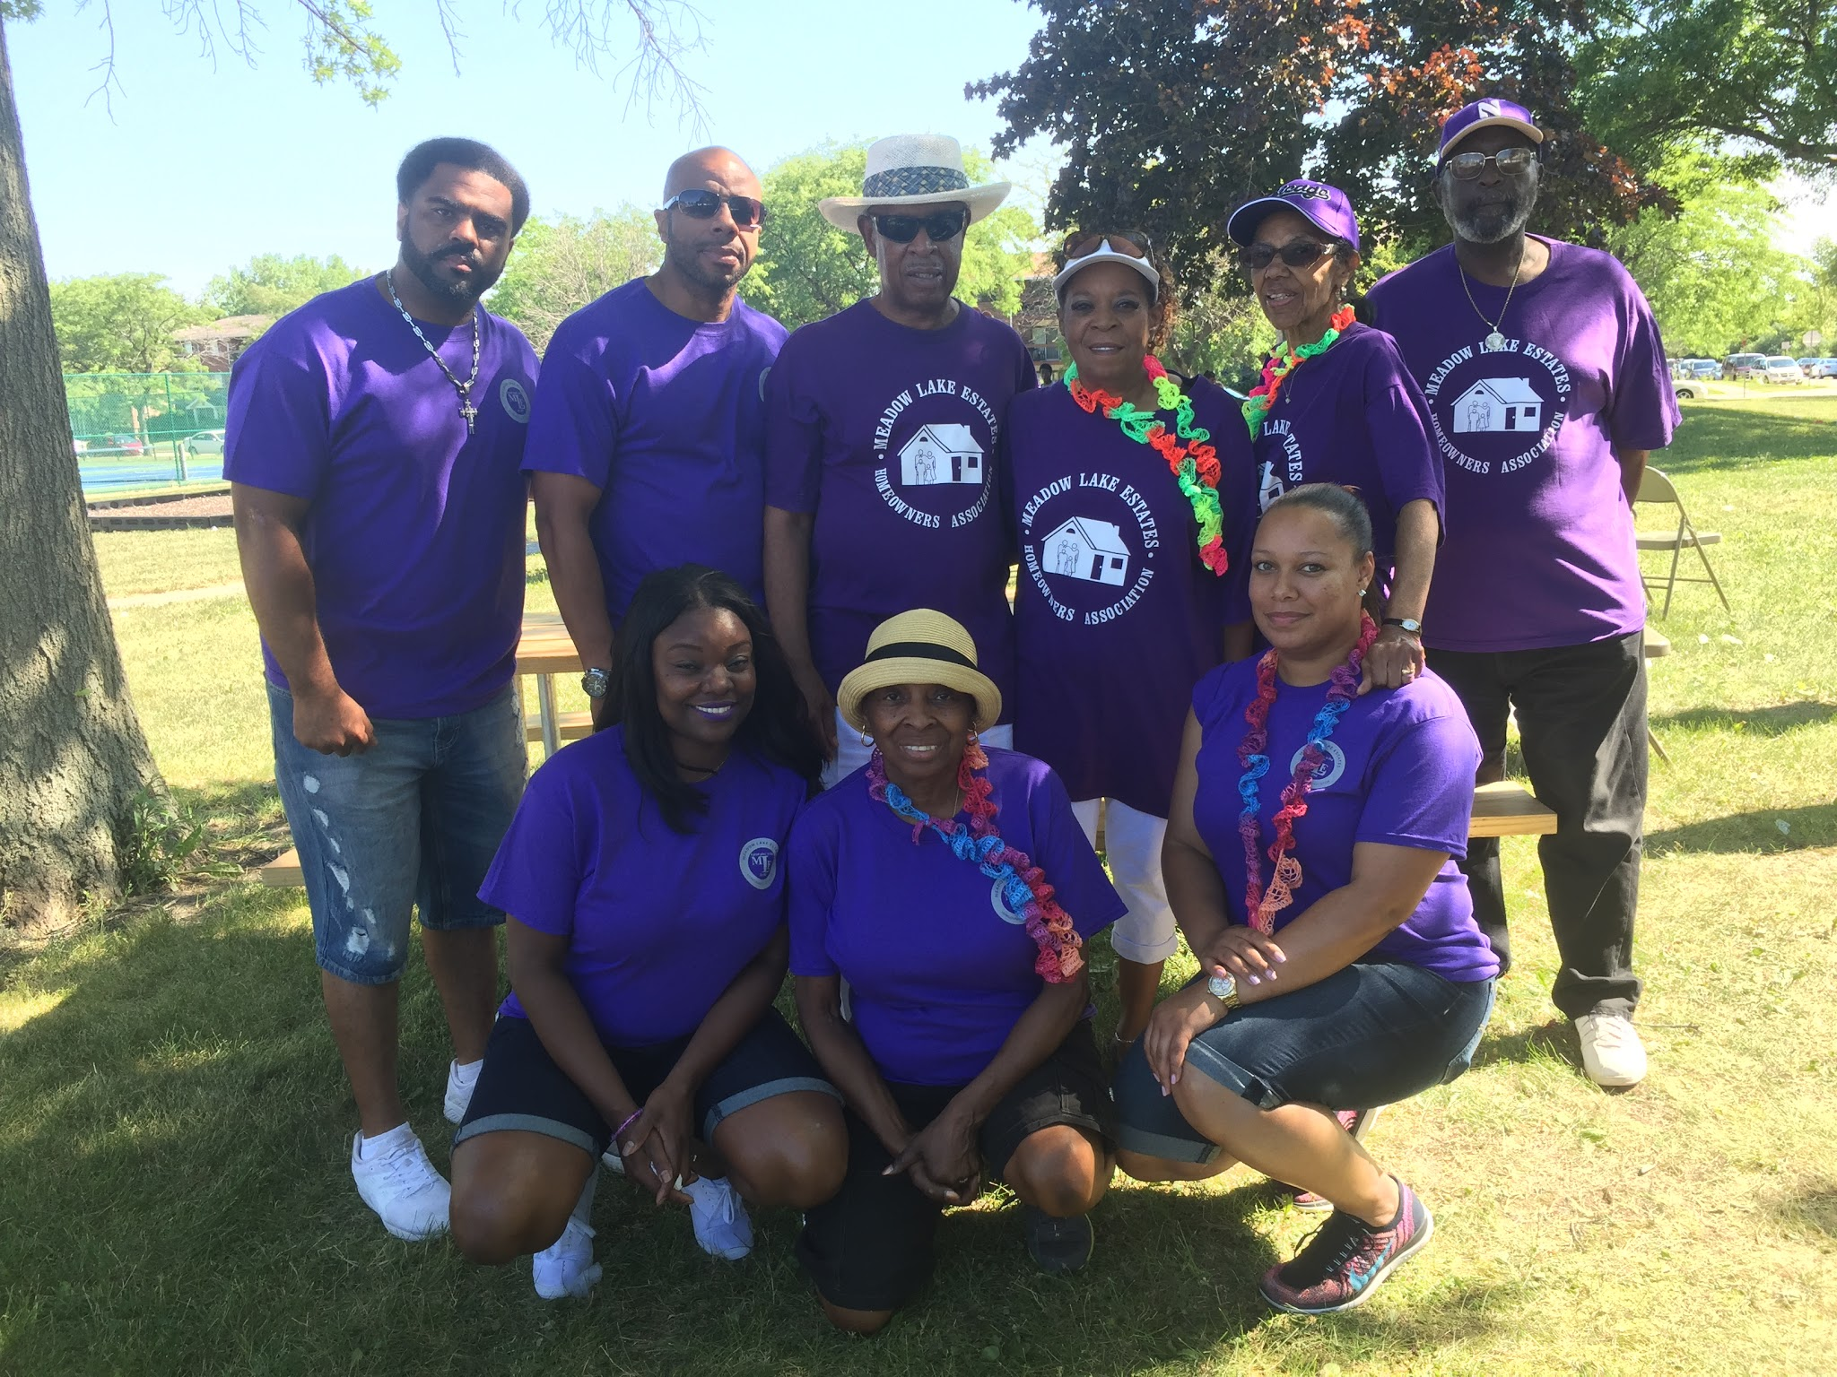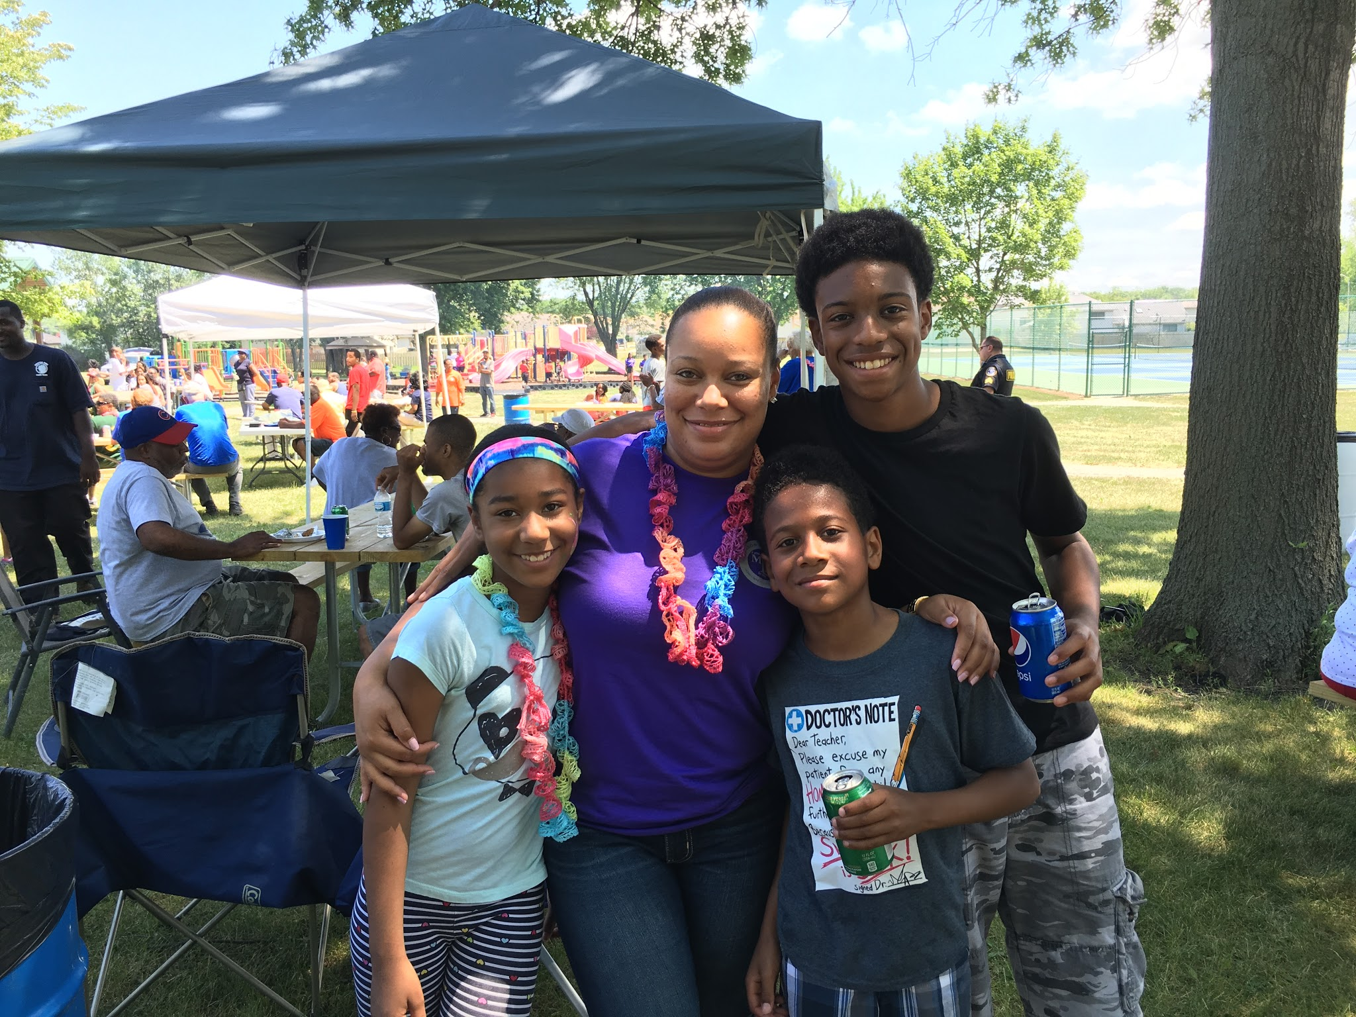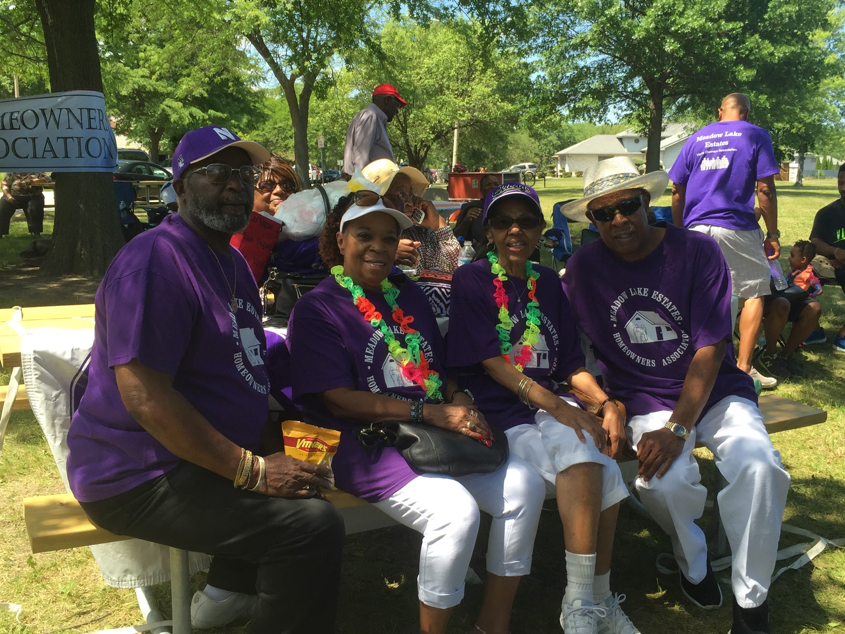

SPECIAL ANNOUNCEMENTS
The Village of Richton Park has selected Mack Companies for the redevelopment of Lakewood Plaza Shopping Center. Mack Companies is one of the largest of new and redeveloped real estate. Mack is reaching out to Trader Joe’s, Red Robin, Pier One Imports, Sonic and a host of other potential clients that would be an attractive addition to Richton Park and our community.

ADDITIONAL ANNOUNCEMENTS
*We are still taking school supply donations and volunteers to serve for the Family Affair picnic. Please contact Annette Ware (708)828-0955*
*Meadowlake shirts are for sale while supplies last!! $15 adults, $12 kids*
EXECUTIVE BOARD  Antonio Belton-President (312)320-6188  Carl Scott-Vice President (773)610-7733  Annette Ware-Treasurer (708)828-0955  Darnell Langston-Sgt at Arms (708)420-6316  Dreyanna Scott-Secretary (708)522-1240 | BLOCK CAPTAINS  Tommie Garner - Chairman: 747-9889  Dan Brown-Meadow Lake Dr: 748-6553  Rhone Terrell - Meadow Lake Dr: 503-0273  Antonio Belton - Meadow Lake Pl: 503-0421  Steve Tyson - Brook Ave: 552-6397  Rosie Dagon- Meadow Lake Ct/Drive: 481-6253  Larry Newman - Spring Lane/Court: 481-8503  Henry Ehizemwogie - Neptune: 503-9648  Jerry Rials - Sunset Drive: 747-6520  Darnell Langston - Capri Lane: 420-6316  Sherman Hollivay- Harbor Lane  Annette Ware - Bayview Drive: 828-0955  Sharon Kriha - MLE back-up &support: 567-0534

MLE CONTACT
meadowlakeestates.hoa@gmail.com
Like us on Facebook : MLE HOA Richton Park IL

