Happy New Year & Decade MLE Neighbors.
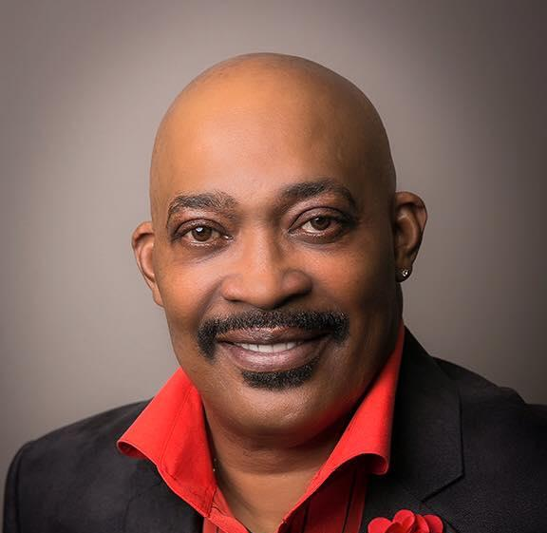
Your newly elected 2020/2021 MLE HOA Executive Board are excited about this New Year and all the possibilities of this New Decade. We would like to take this opportunity to introduce ourselves to you.
President: Mr. Julian Alexander (Carol)
father, grandfather, Village Trustee
4988 Meadow Lake Drive, 21 Year Resident
Originally from Chicago
Bulls & Bears Fan
Vice President: Mr. Antonio “Tony” Belton (Rochelle)
4808 Meadow Lake Dr
MLE Resident for over 16 years
Originally from The Wild 100s- 109th & Morgan
“Next time ya see me- holla like ya know me!”
Secretary: Mrs. Beverly Harris (Edwin)
wife to Edwin, mom of three young adults
Glam Ma in a couple of weeks
4918 Bay View Drive
MLE Resident for over 7 years
Born and raised in the South Suburbs (Wildcat for life)
Grateful for the opportunity to serve our community
Treasurer: Mr. Patrick Napue (Sherrie)
father and life of the party
22044 Sunset Drive
Originally from Minneapolis...Viking Fan
Loyola University Graduate
Accounting/Finance Professional
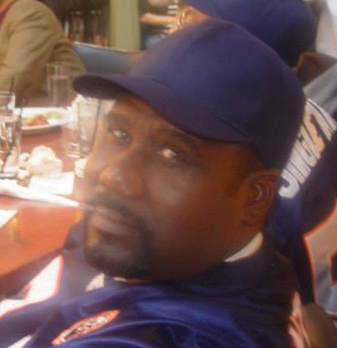
Sgt. at Arms: Mr. Aaron Reaves,
father and grandfather
Honorably Discharged from the US Marine Corps
4973 Meadow Lake Drive
Meadow Lake Resident for 6 years
involved with several groups/organizations in Richton Park

Your MLE HOA Meeting |  | DUES, DUES..OH, DUES!! |  | Prayers
Thursday, February 27th @ 7:30pm  Speakers from our Village  Community Relations  Finance  Parks & Recs.  In an effort to keep our community safe, we are encouraging everyone to be aware of suspicious activity in and around your home and the subdivision. Keep your doors and car doors locked and Please report any and all suspicious activity to the Richton Park PD. Thank you in advance for helping us keep our homes and the homes of our neighbors safe..  If you would like to receive electronic communication from the HOA of things like the Monthly Newsletter, Special events, updates, etc. Please send an email to us at meadowlakeestates.hoa@gmail.com with your name, email and number. |  | MEADOWLAKE MEMBERSHIP DUES ARE DUE FOR THE 2020-2021 YEAR!!!!! THE FEE IS $40 PER FAMILY. YOUR DUES AND DONATIONS GO TOWARDS ALL YEARLY EVENTS, TOWARDS THE BEAUTIFICATION FOR OUR ENTRYWAY, OUR BACK-TO-SCHOOL EVENTS FOR OUR KIDS, ETC. PLEASE SUPPORT YOUR MLE COMMUNITY TODAY!!!! A New Year is a great time to get involved. Your presence and efforts are WANTED, NEEDED and Appreciated!!!  Subdivision Roster  We want to keep you informed and updated of things going on in our community. We would like to send you voice calls. Please make sure we have your correct Name, Number, Address and Email in our roster. You can send all information to the homeowners email at meadowlakeestates.hoa@gmail.com or call our Secretary Beverly Harris (708)307-5150 to update. Thank you for helping us stay connected with one another. |  | Continued Prayers for all MLE residents that may be caring for loved ones at this time. May the Lord give you the strength and keep your body healthy while you are caring for others. If you or anyone in our subdivision has experienced illness or loss please don’t hesitate to let us know so that we can send cards and acknowledgements.  You can send all information to Beverly Harris at ladybevharris1@gmail.com or call at 708-307-5150.  Prayers  Kenneth Earl Smith Sr. in the lost of his brother Robert Lee Smith Jr.  Dreyanna Scott and family as they care for and are concerned about their sister Tabatha LaDawn-Gibson  Celebrations  Happy Birthday & Happy Anniversary  To all MLE residents that celebrated a Birthday or Anniversary in the months of  January & February

MLE Fundraiser
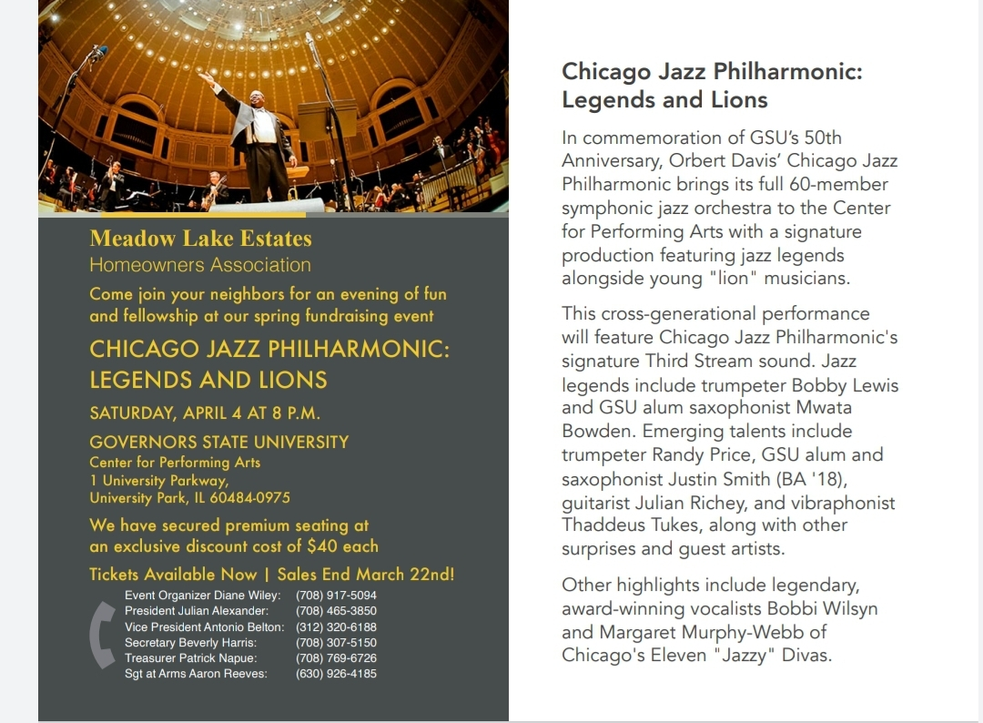
EXECUTIVE BOARD  Julian F. Alexander Sr. - President  (708) 257-5948  Antonio Belton - Vice President  (312) 320-6188  Patrick Napue - Treasurer  (708) 769-6726  Beverly Harris - Secretary  (708) 307-5150  Aaron Reaves - Sgt. at Arms  (630) 926-4185  MLE CONTACT  meadowlakeestates.hoa@gmail.com |  | BLOCK CAPTAINS  Tommie Garner: Chairman 747-9889 Dan Brown: Meadowlake Drive 748-6553 Scot Scott: Meadowlake Drive 275-8619 Carolyn Brown: Meadowlake Place 860-8526 Steve Tyson: Brook Ave 552-6397 Rosie Dagon: Meadowlake Court 481-6253 Larry Newman: Spring Lane/Court: 481-8503 Henry Ehizemwogie: Meadowlake Drive (773) 574-4825 Jerry Rials: Sunset Drive 747-6520 Darnell Langston: Capri Lane 420-6316 Shawntora Harvey: Harbor Lane (773) 909-9325 Fred Williams Jr.: Neptune Lane (219) 680-6521 Beverly Harris: Bayview Drive (708) 307-5150 Sharon Kriha: MLE back-up (708) 503-8550
Village of Richton Park Directory:

Administration : (708) 481-8950 Police (non emergency) (708) 283-6593
Community Center : (708) 753-8800 Police (Dispatch) (708) 481-8911
Community Services : (708) 753-8800 Public Works (708) 481-8950
Parks & Recreation : (708) 753-8800
Community & Economic Development : (708) 481-5086
Code Enforcement : (708) 481-8950
Finance : (708) 481-8950
Fire Department (Non Emergency) : (708) 481-8980

