- Newsletter
  - Into
Hello everyone, Its hard to believe its that time of year already. Halloween is just a week away, Thanksgiving is right around the corner and the Holiday season will be upon us very soon.We are planning for our MLE Annual Christmas Gala. We are excited to announce we are trying something new this year. We will hold the event at the Richton Park community center. Tickets will be available this Thursday at the HOA meeting on October 27th. Please contact any member of the Executive Board or your Block Captain to purchase your tickets early.
  - Youth behavior at McDonald's & other businesses
    - Check your kids
Halloween safety & protocol
Monday 10/31 3-8 pm
Porch light on to indicate participation
Add home to treat map on Nextdoor
When driving throughout the subdivision on Halloween, please be mindful of the Trick or Treaters crossing the streets as they walk door to door. Trick or Treating is allowed between 3pm-8pm. If you will have candy to pass out, please remember to cut your porch lights on. After 8pm, the RP Police will be driving through the subdivision to ensure no children are still out.
  - Christmas gala tickets on sale
    - Add flyer to newsletter check events folder or copy from below
    - 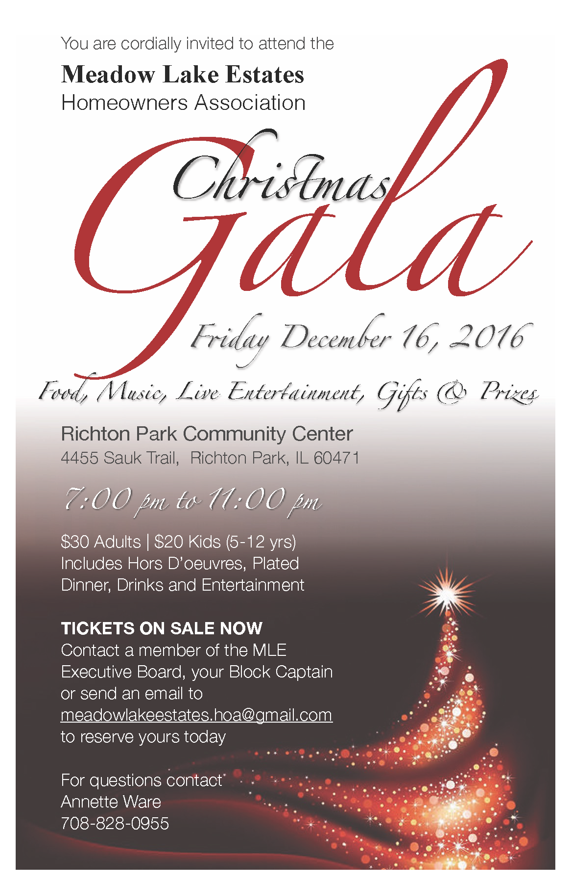
  - Adopt A Family
Our annual Adopt-A-Family efforts are currently underway. Two families have been chosen for this years charity drive. The effort this year will be lead by MLE Board Treasurer Annette Ware. Detailed information regarding the families MLE has adopted this year will be shared with all our residents in a separate communication.
During this holiday season, please keep in mind those that are less fortunate and please consider donating to this worthy cause. A small monetary donation can go a long way in making a child's Christmas wishes come true. We will be calling for volunteers to assist with various aspects and donations to ensure that this great Meadow Lake Estates tradition is a success.
Please contact Annette Ware @ (708) 828-0955 for ways you can help get involved
  - Rising Star Ball
    - Check with Annette
  - Congratulations Carl Scott
    - 2x I Make a difference award winner
  - Call for volunteers to run for school board
    - Contact Shawntora Harvey
  - Call for business owners to advertise through newsletter
  - Trail of treats Saturday
    - 10/29 RP Community center 3-5

