It’s that time of year again. Yup, you guessed it HOA fees are due for 2017. Meadow Lake Estates has traditionally been the strongest HOA in Richton Park and we strive to maintain that status. To do so we need your help, initially in the form of your paid membership into our HOA. Keep in mind that our $40 membership fee is one of the lowest you’ll find in any community. Your participation goes a long way toward helping us perform all the engagements and activities we’ve become known for. Our goal is to boost our participation so that we can bring you even more value. Along with your paid membership we ask for your participation. If you have a skill to share or an interest that you think other might enjoy, let us know about it. Come to a meeting or hang out at one of our events. Let’s show how strong of a community Meadow Lake Estates is. This is our home and we all need to do our part to maintain it.
Antonio Belton
MLEHOA President 2016-2017

Now Hear This

MLE HOA Annual Membership Dues
The MLE HOA Membership Drive will be on Saturday, April 11th from 10am -12pm (weather permitting). During this time the Executive Board will be stationed near the entrance to the subdivision and our block captains will be going door to door to introduce themselves and provide each resident with a membership form. The annual membership fee is $40.00 for the year and can be paid during this time. It’s a perfect opportunity to get to know your neighbors as well as get involved in the association.

MLE HOA Accomplishments and Benefits
Government Engagement  - We are the strongest HOA in the village of Richton Park  - We represent your need at the Richton Park village board meetings  - We actively pursue property tax reduction through group filing activities  - We monitor village fee - water, auto registration, etc.  - We hold the village responsible - elected officials, police, fire, etc.  - We have helped acquire new larger drains to stop neighborhood flooding  - We provide an impartial platform for political candidates to voice their intentions for providing excellent service to our community  - We monitor grade and high school progress  Around the Neighborhood  - We provide you with timely news and updates that affect our community via newsletter and e-mail  - Block Captains are available to address your neighborhood concerns | - We maintain and beautify the subdivision entry way  - We monitor garbage pick-up  - We monitor snow shoveling  For Your Safety  - We’ve reinvigorated the Neighborhood Watch  - We actively engage in gang prevention  - We encourage animal control  - We monitor home vacancies  Outreach  - Christmas season Adopt-A-Family program  - Annual back-to-school supply drive and donation  Social Activity  - Annual Easter Egg Hunt  - Annual Family Picnic  - Annual Christmas Gala  - More to come…..

MLE HOA Meeting
Thursday February 23rd 7:30pm Village of Richton Park Board Room
Mark your Calendars! |  |  | Prayers and Condolences
MLE Easter Egg Hunt will be held on Saturday, April 8th in Christina Covington Memorial Park at 11am - 1pm. It should be a fun time held by all the children of MLE. |  |  | We wish Mr. Ozzie Gibson and Verdell Iverson Parker, father and grandmother (respectively) of Dreyanna Scott a speedy recovery from their recent ailments.  Our condolences go out to Scot Scott and his family on the passing of their loved one, Michelle Marr-Bray
VILLAGE EVENTS |  |  | CONTACT INFO
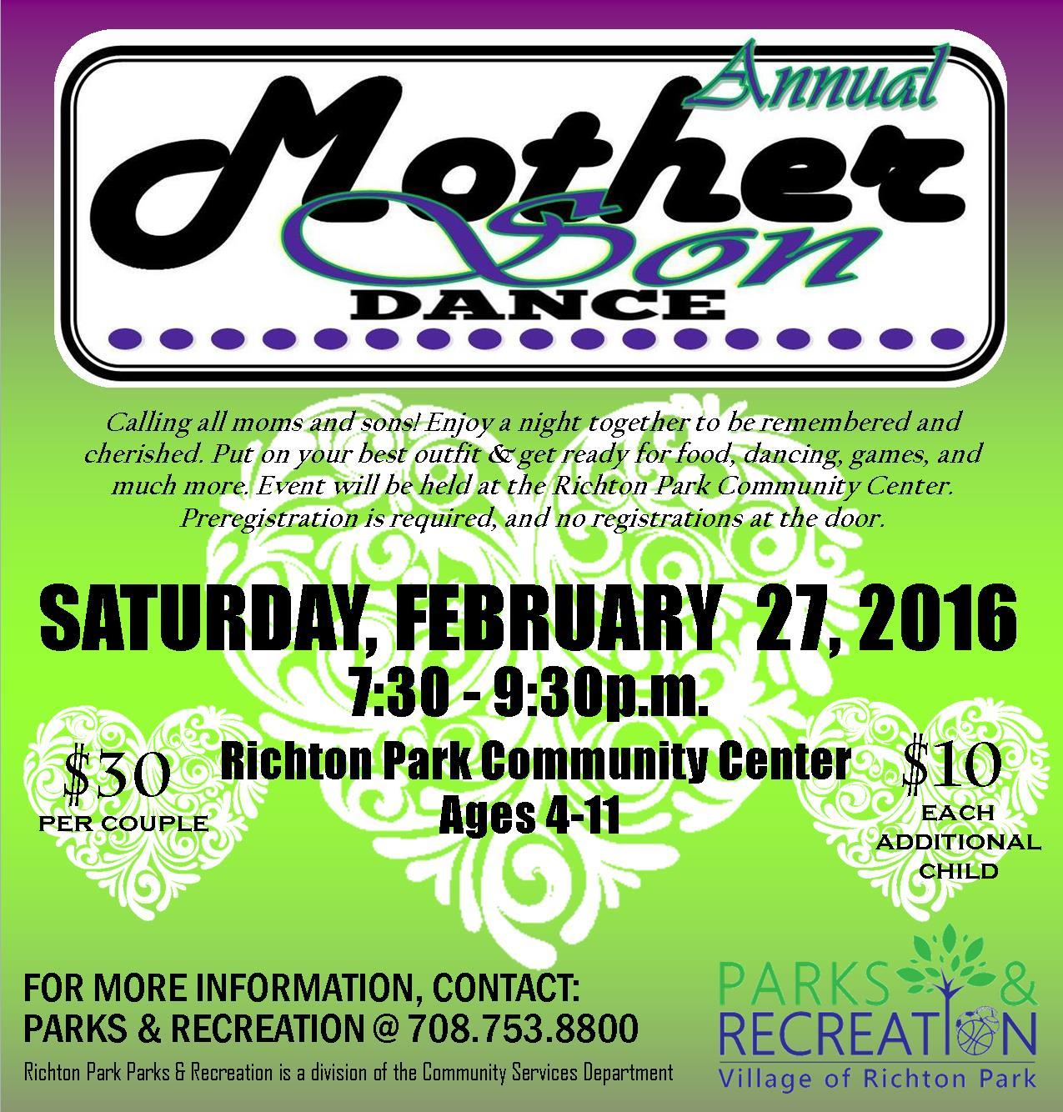 |  |  | EXECUTIVE BOARD  Antonio Belton - President  (312) 320-6188  Carl Scott - Vice President  (773) 610-7733  Annette Ware - Treasurer  (708) 828-0955  Dreyanna Scott - Secretary  (708) 522-1240  Darnell Langston-Sgt at Arms  (708) 420-6316  MLE CONTACT  meadowlakeestates.hoa@gmail.com

BLOCK CAPTAINS
Tommie Garner: Chairman
747-9889
Dan Brown: Meadow Lake Drive
748-6553
Carolyn Brown: Meadow Lake Place
860-8526
Steve Tyson: Brook Ave
552-6397
Rosie Dagon: Meadow Lake Court
481-6253
Larry Newman: Spring Lane/Court: 481-8503
Henry Ehizemwogie: Meadow Lake Dr (773) 574-4825
Jerry Rials: Sunset Drive
747-6520
Darnell Langston: Capri Lane
420-6316
Sherman Hollivay: Harbor Lane
(708)285-4344
Annette Ware: Bayview Drive
828-0955
Sharon Kriha: MLE back-up
567-0534

